The Five Parenting Systems - Jonathan Baylin and Dan Hughes

Failure of the Parental Executive System to regulate unparental reactions suppresses all parenting systems.

Parental Meaning – Making System



(Weak)

“ON”

“Off”

Parental Child Reading System

SELF-DEFENSE SYSTEM

Parental

Executive

System

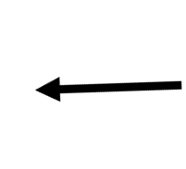

“Unsafe”

Parental Approach System

Amygdala

Parental Reward System